Chapter 17, Problem 33.

In the circuit shown in Fig. 17.69, the Fourier series expansion of v_{s}(t) is

Find v_{o}(t).

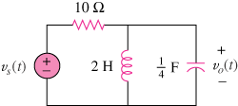

Figure 17.69
For Prob. 17.33.

